Project Development Phase
Date | 31 January 2026
Team ID | LTVIP2026TMIDS28502
Project Name | Visualizing Housing Market Trends: An Analysis of Sale Prices and Features using Tableau

Project Name: Visualizing Housing Market Trends: An Analysis of Sale Prices and Features using Tableau
Team ID: LTVIP2026TMIDS28502
Dataset: Transformed_Housing_Data2.csv
Tools Used: Tableau Desktop, Tableau Public, Flask, Python

1. Data Connectivity
Data connectivity is the process of connecting the housing dataset to the Tableau visualization tool for analysis and dashboard creation.
Steps Performed:
- The housing dataset file Transformed_Housing_Data2.csv was downloaded from Kaggle and stored on the local system.
- Tableau Desktop was launched and the dataset was connected using the “Text File” connection option.
- Tableau automatically detected the dataset structure and classified fields into dimensions and measures.
- The dataset was successfully loaded into Tableau, enabling further analysis and visualization.
- All columns such as Sale Price, House Age, Renovation Status, Basement Area, Bedrooms, Bathrooms, and Floors were verified for correct data types.
Outcome:
The dataset was successfully connected to Tableau Desktop and made ready for preprocessing and visualization.

2. Data Preparation (Preprocessing Steps)
Data preparation ensures that the dataset is clean, structured, and suitable for accurate visualization and analysis.
Preprocessing Steps Performed:
2.1 Data Cleaning
- Verified dataset for missing or null values.
- Ensured numerical fields such as Sale Price and Basement Area were correctly recognized as numeric measures.
- Ensured categorical fields such as Renovation Status were correctly recognized as dimensions.
2.2 Data Transformation
- Renamed columns for clarity and readability where necessary.
- Verified data consistency across all records.
- Created calculated fields if required for improved analysis.
2.3 Data Classification
Tableau automatically classified:
Dimensions:
- Renovation Status
- Bedrooms
- Bathrooms
- Floors
Measures:
- Sale Price
- Basement Area
- House Age
2.4 Data Validation
- Verified dataset accuracy using Tableau preview.
- Confirmed that data was correctly loaded without corruption or errors.
Outcome:
The dataset was cleaned, prepared, and validated for visualization.

3. Dashboard Development
The dashboard was created using Tableau Desktop to provide interactive visualization of housing market trends.
Dashboard Components:
KPI Indicators
- Total number of houses
- Average Sale Price
- Total Basement Area
Visualizations Created
- Bar Chart: Total Sales by Years Since Renovation
- Pie Chart: Distribution of House Age by Renovation Status
- Bar Chart: House Age Distribution by Bedrooms, Bathrooms, and Floors
Dashboard Features
- Interactive filters for Sale Price and House Age
- Clear layout with organized visualizations
- User-friendly and readable design
Outcome:
An interactive dashboard was created to help users analyze housing trends effectively.
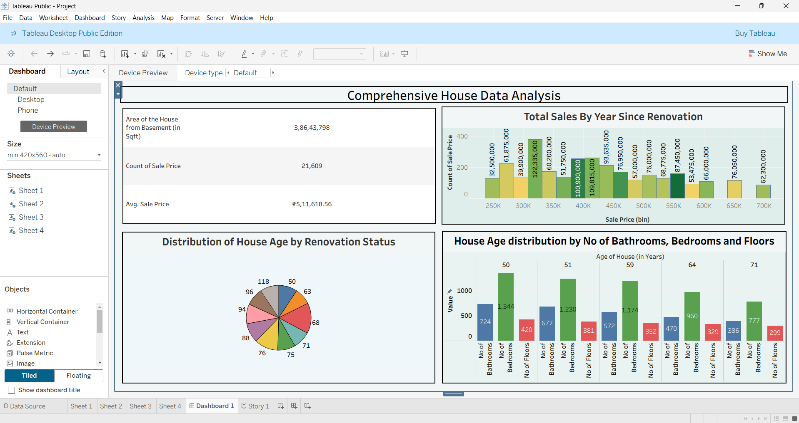
4. Story Creation
A Tableau Story was created to present insights in a structured and logical sequence.
Story Components:
Scene 1: Dataset Overview
- Shows total houses and average sale price
Scene 2: Renovation Impact Analysis
- Shows relationship between renovation and sale price
Scene 3: House Age Analysis
- Shows age distribution of houses
Scene 4: Feature-Based Analysis
- Shows comparison of housing features
Outcome:
The story provides a step-by-step explanation of housing market trends.
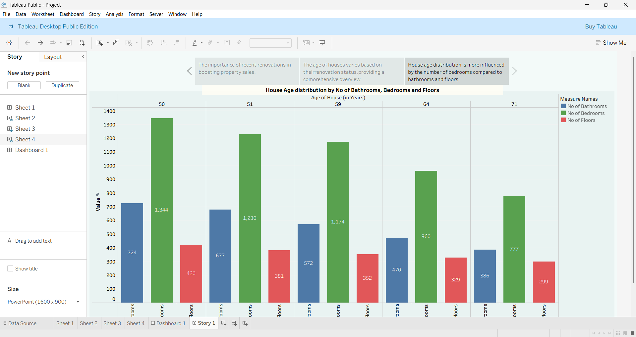
6. Dashboard Publishing
The dashboard and story were published to Tableau Public.
Steps performed:
- Logged into Tableau Public account
- Published dashboard
- Generated public dashboard link
- Verified dashboard accessibility
Outcome:
Dashboard is accessible online and ready for demonstration.

7. Web Integration using Flask
The Tableau dashboard was integrated into a Flask web application.
Steps performed:
- Created Flask application folder
- Created app.py and HTML template
- Embedded Tableau dashboard using iframe
- Ran Flask server successfully
- Verified dashboard display in browser
Outcome:
Dashboard successfully integrated into web interface.

